**Names: 1.** Dushimirimana Aristide

**EXRICESEcd**

**1.** 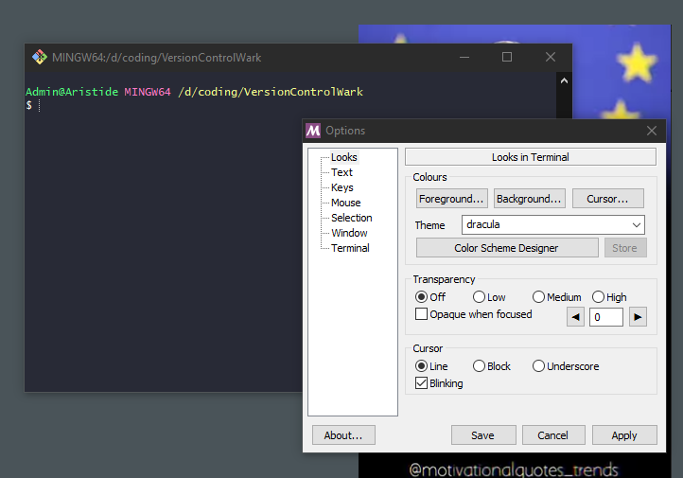

**2.** to check the version of git bash you use

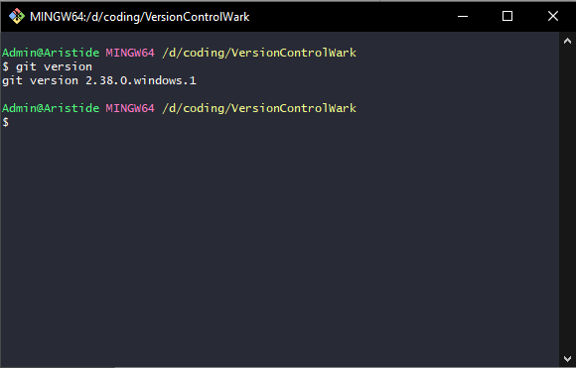

**4.**  To run git show first create repository with git init then open repository with CD or you can call the existing from disk C with CD command . TO close the repository use CD –- command

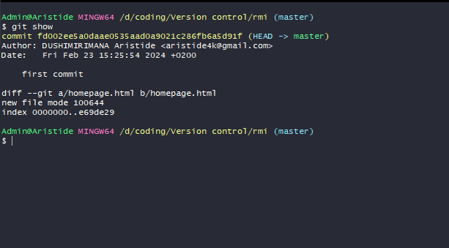

**5.**

Exercise to be used:first way with creating offline repository with the same name online

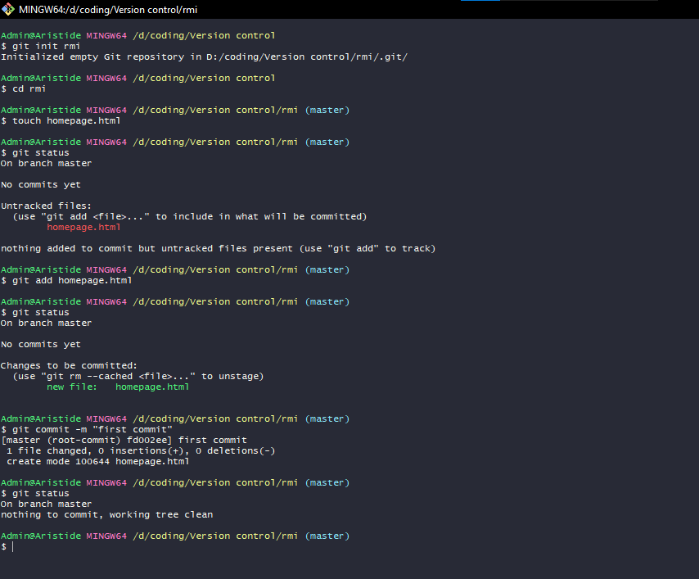

**5.** 